What is Permutation?
A permutation is an arrangement of objects in a particular order.
In math, a permutation is an arrangement of items in a specific order. The order matters, which means changing the position of the items creates a different permutation.
For example, if we have the letters A, B, and C, the possible permutations include:
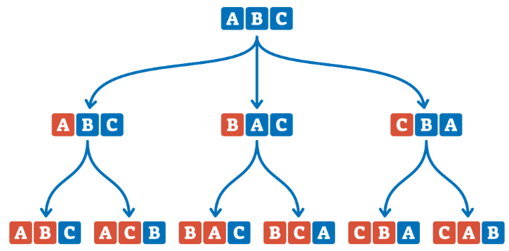
Why does order matter?
Consider:
These two contain same letters, but their order is different.
Therefore, they are considered two different permutations.
Formula
If we have n distinct objects and want to arrange r objects at a time, the number of permutations is:
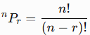 = 10!/(10-4)! = 10!/6! = 10 x 9 x 8 x 7

Examples
1) In how many ways can 5 students stand in a line? 5! Ways = 120
2) In how many ways can 6 different books be arranged on a shelf? 6! ways
3) How many different 4-digit numbers can be formed using 1, 2, 3, 4, 5 without repetition? ${}_{}^{5}{P_{4}}$ = 120
4) From 8 students, in how many ways can 3 students be selected and arranged for the positions of President, Secretary and Treasurer? ${}_{}^{8}{P_{3}}$ = 336
5) A company has 7 employees. In how many ways can it assign Manager, Team Leader and Developer positions to different employees? ${}_{}^{7}{P_{3}}$ = 7 x 6 x 5 = 210
6) A college has 8 students participating in a debate competition. The organizers need to decide the order in which the students will speak. In how many different ways can the speaking order be arranged? 8!
7) Five students have to give presentations on the same day. How many different presentation schedules are possible? 5! = 120
8) A system generates a password consisting of 4 different digits selected from 0–9. How many such passwords are possible?
9) An OTP consists of 4 digits. How many different OTPs can be generated if repetition is not allowed?
10) A company has 6 servers and wants to assign three different roles: Web server, Database server and Backup server. Each role must be assigned to a different server. In how many ways can the roles be assigned?
11) A network engineer has 5 different routers available. Three routers need to be selected and arranged in a specific order for a test network. How many possible arrangements are there?
12) In how many ways can 7 people be arranged if two particular people must always be together?

Permutation with repetition
A permutation with repetition allows
1. items to be chosen more than once
2. or involves arranging a set that contains identical items

1. Items to be chosen more than once
Formula:
If there are n choices for each object and can be selected r times, then possible permutations are $n^{r}$.
1) How many 3-digit numbers can be formed using the digits 2, 3, 4, 5 and 6 if repetition is allowed? N = 5, r = 3, so n^r = 5^3 = 5 x 5 x 5 = 125
2) How many 4-digit PINs can be made using digits 0 through 9 if numbers can repeat? = 10^4 = 10 x 10 x 10 x 10 = 10000

2. Arranging sets with identical/repeating objects
If there are n objects where there are $n_{1}$ repeated items, $n_{2}$ repeated items, ….. $n_{k}$ repeated items, then the number of different permutations are
$$\frac{n!}{n_{1}!n_{2}!….n_{k}!}$$
1) Find the number of unique arrangements for the letters in "BOOK" 4!/2!
2) Find how many ways you can rearrange letters of the word “BANANA” all at a time. 6!/(3!.2!) = 6 x 5 x 4 x 3!/(3!.2!)
3) Find the number of arrangements of the word BALLOON. 7!/(2!.2!)

